http://xmlspawner.15.forumer.com/index.php?showtopic=415

ArteGordon | Posted: May 08, 2006 07:07 pm
  God of XMLSpawner  Group: Admin  Posts: 2,899  Member No.: 2  Joined: December 26, 2005 | By default, spawn location is randomly selected from within the spawning area defined by SpawnRange or X1Y1 X2Y2.  By adding one of the following control keywords to the beginning of the entry, several different positioning methods can be used.  #XFILL[,inc] will add spawns by filling the spawn area progressively in rows of X.  #YFILL[,inc] will add spawns by filling the spawn area in rows of Y.  #EDGE[,inc] will add spawns only around the edge of the spawn area.  These can be used to systematically fill spawning areas, when random positioning is not desired.  An additional optional increment value can be passed as an argument to these keywords to change the spacing between successive spawn positions.  #PLAYER[,range] - places the spawns around the triggering player.  #WAYPOINT,prefix[,range] - places the spawn at the location of randomly selected waypoint runes that start with the given prefix.  spawn the specified statics only around the perimeter of the spawing area.  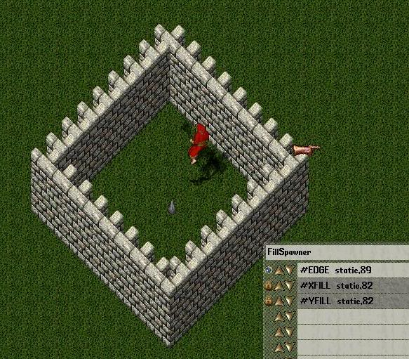  fill the spawning area with the given static.  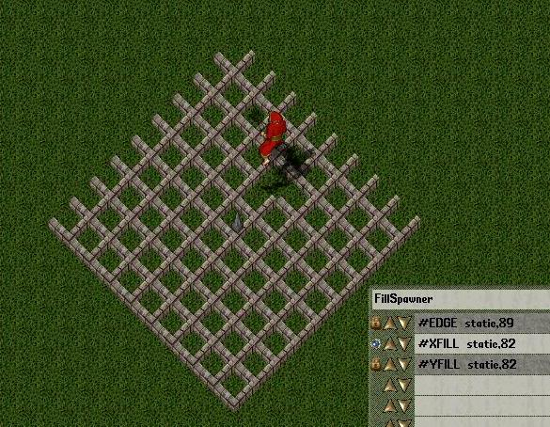  the same thing, but fill first along Y instead of X.  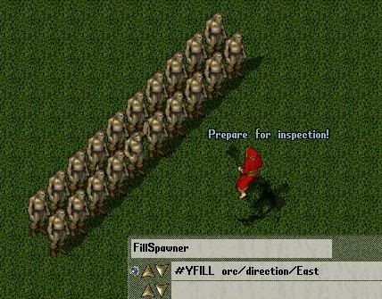  spawn a group of orcs within 2 tiles of the triggering player.  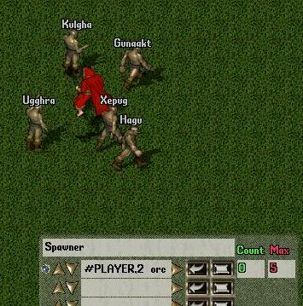  place spawns at the randomly selected named waypoints.  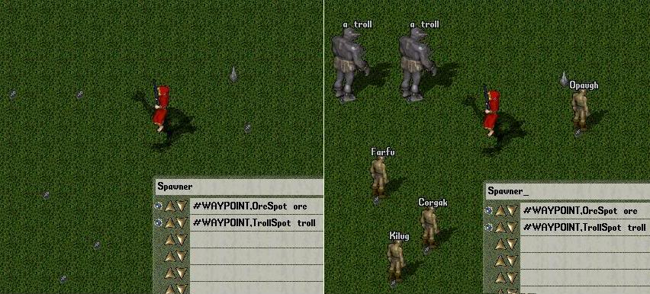  spawn around the edge with spacing between them.  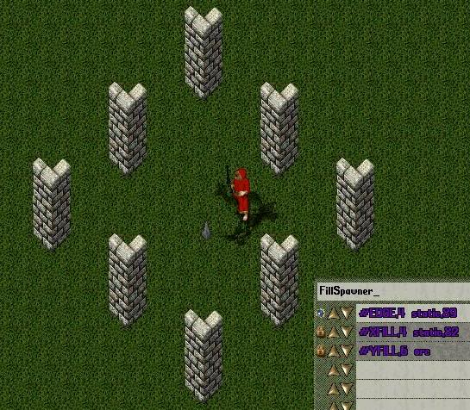  --------------------  

Vladimir | Posted: May 27, 2006 02:48 pm
Senior Member  Group: Members  Posts: 112  Member No.: 121  Joined: April 23, 2006 | Hi there, i'm having a little trouble with this...  I set the spawn range to find and in the first entry i put:  #XFILL mandrakeplant  I then get an Invalid type specification error? what did i miss?

ArteGordon | Posted: May 27, 2006 03:12 pm
God of XMLSpawner  Group: Admin  Posts: 2,899  Member No.: 2  Joined: December 26, 2005 | the latest version (v3.10) added a requirement for a semicolon between the control keywords and the regular entry. So,  #XFILL ; mandrakeplant  --------------------
  QUOTE (Vladimir @ May 27, 2006 09:48 am)
  Hi there, i'm having a little trouble with this...
  I set the spawn range to find and in the first entry i put:
  #XFILL mandrakeplant
  I then get an Invalid type specification error? what did i miss?

Vladimir | Posted: May 27, 2006 08:24 pm
Senior Member  Group: Members  Posts: 112  Member No.: 121  Joined: April 23, 2006 | Ahh sorry didn't pick that up Thx for the help

